# http://euniceandmax.com/assets/BlackDog01_Purple.L.gif Eunice & Max - April 26, 2015

**Directions to Outdoor Art Club, Mill Valley, CA**

### **FROM EAST BAY AND 101 NORTH**

* Take 580 to Richmond Bridge
* Exit Sir Francis Drake Blvd (right after bridge) for 101 SOUTH
* Follow Sir Francis Drake to 101 SOUTH in Larkspur
* Follow 101 South for approximately 3 miles and EXIT at E. BLITHEDALE
* Right turn off of Exit.   Follow East Blithedale into Mill Valley and OAC

### **FROM SFO, san francisco and south bay**

* Take 101 to Golden Gate Bridge, Marin County
* Follow 101 North for approximately 10 miles and EXIT at CA-131 TIBURON BLVD / E. BLITHEDALE
* 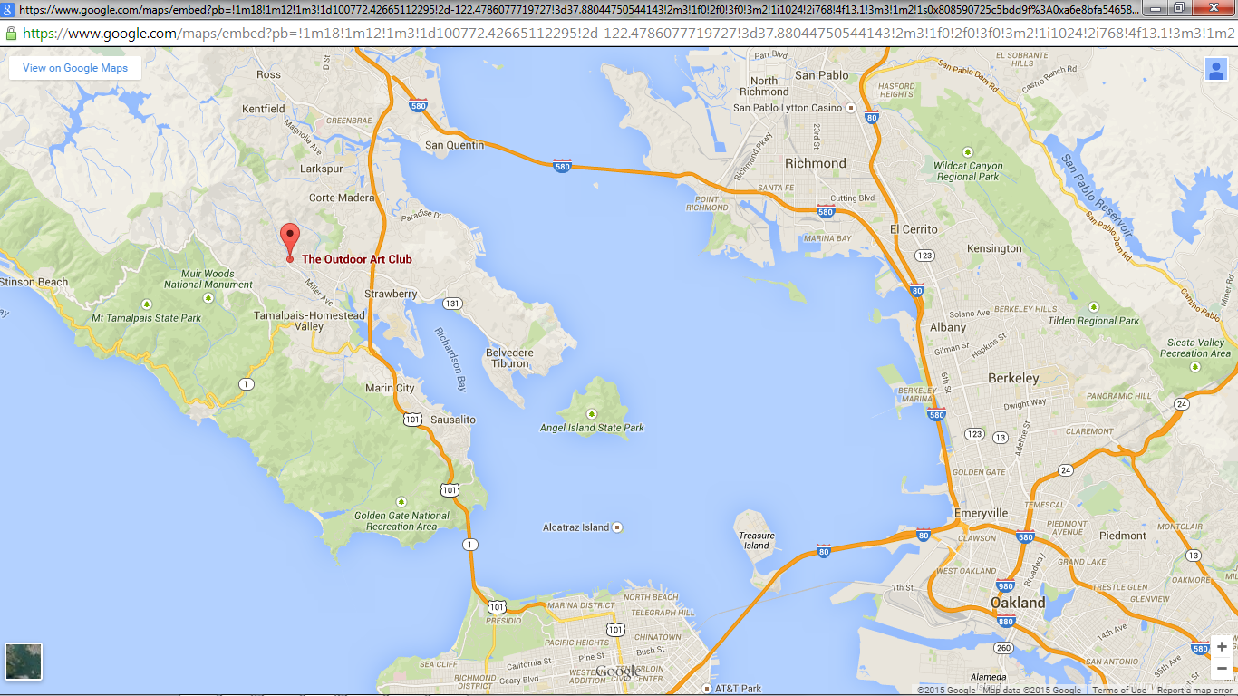Left turn off of Exit.   Follow East Blithedale into Mill Valley and OAC